Joshua Lee

11/8/2014

CMPSC 475

**App Statement**

Title: Super Tic Tac Toe

Description:

Super Tic Tac Toe is a 9x9 twist on the classic Tic Tac Toe game. 2 players take turns placing their marks on smaller 3x3 boards, which are arranged on a large 3x3 board. Each move dictates which small board the next player must play in. If a player “wins” a small board (by marking 3 cells in a line), they earn a mark over that entire small board. To win the game, a player must “win” 3 small boards in a line.

Features:

* Multiplayer gameplay
  + Single Device: Game can be played by 2 people using a single device
  + Multipeer: Game is played over Multipeer Connectivity on two devices
* Mark animations, victory/defeat animations
* Projected moves (before finalizing a move, placing a mark will highlight the small board that the next player will be able to play on)
* Alternate themes
* Music and sound effects
* Save game; Users can exit a game and restore it later.

Audience:

* Kids
* People with time for a game or two while waiting for appointments, lectures, buses, etc.

**Storyboard:**

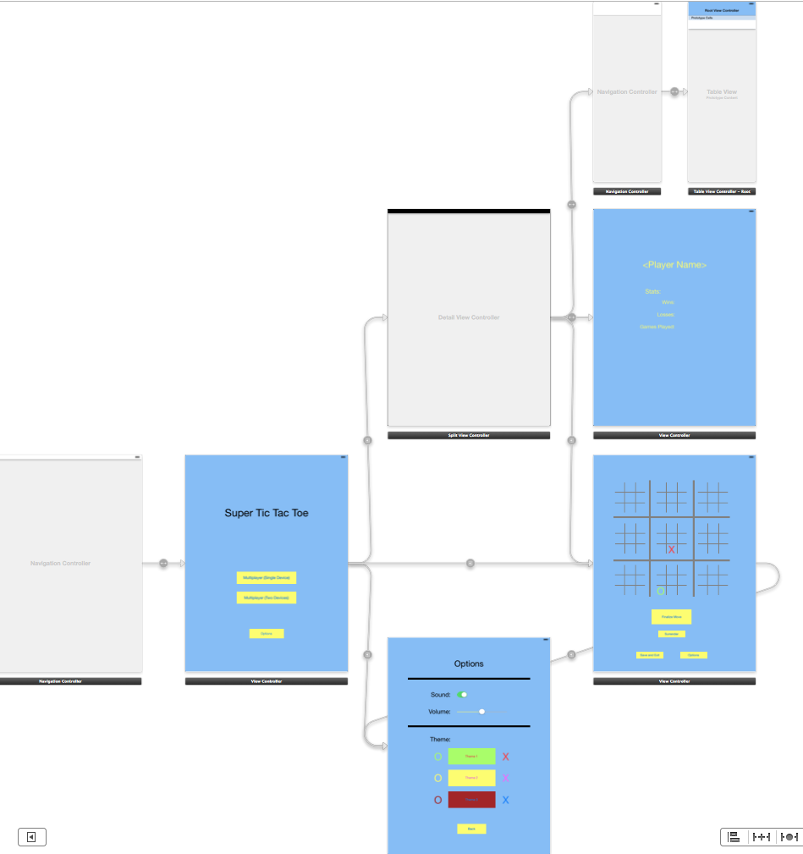

Above: Control flow. From the Main Menu, users may enter a game directly (via “Multiplayer (Single Device)”), go to the Multipeer Menu (via “Multiplayer (Two Devices)”), or configure options (via “Options”). In the Multipeer Menu, users can view a list of possible connections, view player data on those connections, and request to play against someone. In the options menu, users may adjust or toggle volume, and they may select different themes. “Back” dismisses the Options page and shows the parent view controller (either Main Menu or Game). Game displays a board where users may tap to place a mark. Marks are not finalized until the users selects the “Finalize Move” button. Users may surrender, go to Options, or save and exit. Exiting from Game brings the user to the parent view controller (either Main Menu or Multipeer Menu).

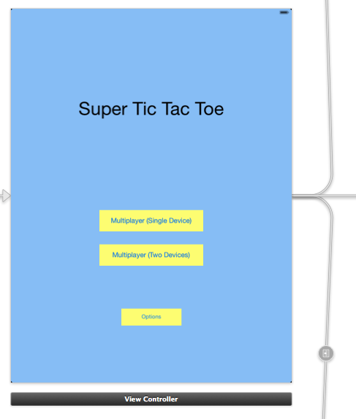Main Menu : Push segues to Game, Multipeer Menu, and Options.

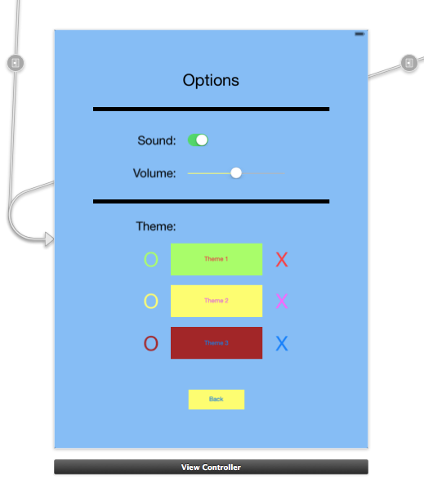Options: Reached by Push segues from Main Menu or Game; Dismissed by parent controller.

Game: Reached by Push segues from Main Menu or Multipeer Menu. Push segue to Options. Users may make their moves by tapping on a valid cell. This will highlight the mini-board that the next player may play on. Users may finalize that move by hitting the “Finalize Move” button. In the instance below, Red went first, and now it is Green’s turn. Green places a mark, and the corresponding board that Red can play on is highlighted. Green must then hit “Finalize Move”, which then passes control to Red.

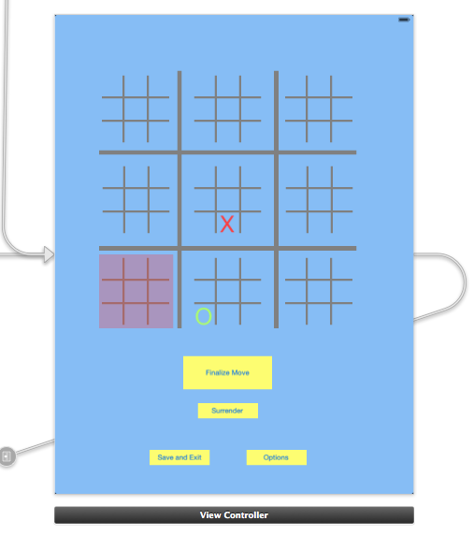

Multipeer Menu – Table View: Displays list of possible connections. Selecting a connection will display relevant player history (if any) in Detail View.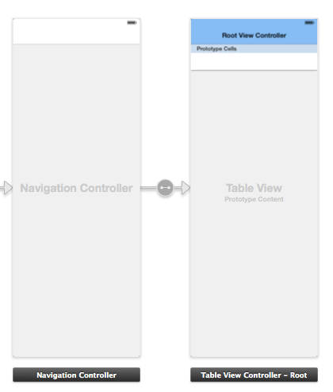

Multipeer Menu – Detail View: Displays relevant player info, if any. Play! button calls a Push segue to Game.

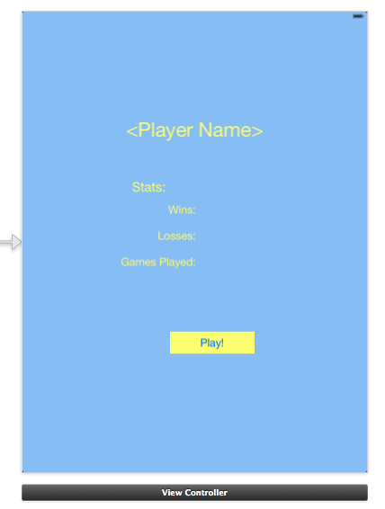

**Technologies and Resources**

Super Tic Tac Toe will utilize the iOS Multipeer Connectivity Framework to connect players.

Assets for the game (images, sound effects and/or music) will be original.

**Tentative Schedule**

* Week 1:
  + Implement a working (perhaps not yet animated or pretty) Multiplayer (Single Device) Game.
* Week 2:
  + Finish up core functionality of Game, if needed.
  + Begin implementation of Multipeer Connectivity (Menu, Game)
* Week 3:
  + Complete implementation of Multipeer aspects.
* Week 4:
  + Implement Options page
  + Implement Sound Effects / Music
  + Clean up or improve details throughout app.

Any extra time will be devoted to generating assets (images, sound effects, music) or fine-tuning details (animations, transitions, layouts).

The schedule has been laid out so as to ensure that core functionality is implemented first and foremost. Auxiliary features (such as themes, sound effects, and music), while nice to have, may be sacrificed if more time must be allocated to core functions and supporting details (animations, transitions).